Intro to Data Communications   
Exploring Network Segments

Last Updated: Version 2  
Document Prepared for: Professor Lindstrom's Student

# Name Peter Sanford ID 10934984

# Instructions

Answer all questions directly in this document. You will save and upload this completed document as your homework submission.

# Overview

In this lab you will explore the effects of separating computers into different network segments, or more accurately into different Local Area Networks (LANs). You will reconfigure your VMs to participate in different LANs by configuring your VMs to use different virtual networks and reassigning IP addresses.

# Setup

You will need your 3 Debian VMs **Do not start them yet**.

# Task 1—Reconfigure your virtual network

For this lab you will need another virtual network in your virtualized network. You will also need to reassign IP addresses for your VMs.

## Steps

1. Configure **Debian-3** to use **VMnet11**.   
   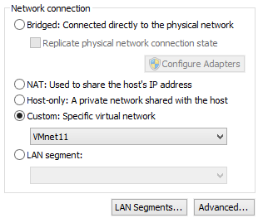
   1. Click OK to close the VM Settings window.
   2. Ensure Debian-1 and Debian-2 are also configured to use **VMnet11**
2. Start your Debian-1, Debian-2 and Debian-3 VMs and login as **root** (password is **Password1**)
3. Reconfiguring IP addresses
   1. In a moment you will configure your VMs to use new IP addresses. The IP address information you will need is as follows. For these addresses you can determine the network address by replacing the last number (the number after the last period) in the IP address with a 0. Fill in the calculated Network Address column:

|  |  |  |  |
| --- | --- | --- | --- |
| VM | IP Address | Subnet Mask | Network Address |
| Debian-1 | 10.0.0.1 | 255.255.255.0 | 10.0.0.0 |
| Debian-2 | 10.0.0.2 | 255.255.255.0 | 10.0.0.0 |
| Debian-3 | 10.0.0.3 | 255.255.255.0 | 10.0.0.0 |

The network address defines the logical network configuration. All computers with the same network address should be able to communicate with each other on a properly configured network.

* 1. Are all of the above addresses on the same network? Yes
  2. Should all the computers be able to communicate with each other? Yes
  3. Complete the following configuration on **each** of your Debian VMs:
     1. Open the network configuration tool, **Start Menu🡪Internet🡪Wicd Network Manager**. You should see the Wicd Network Manager dialog.  
        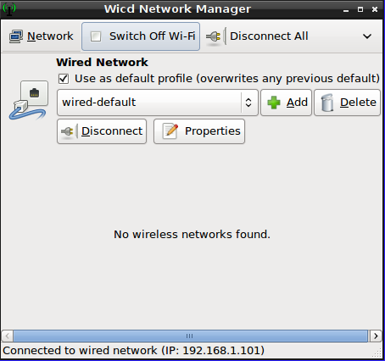
     2. Ensure the wired-default network adapter is selected (it should be) then click Properties. You should now see the following dialog.  
        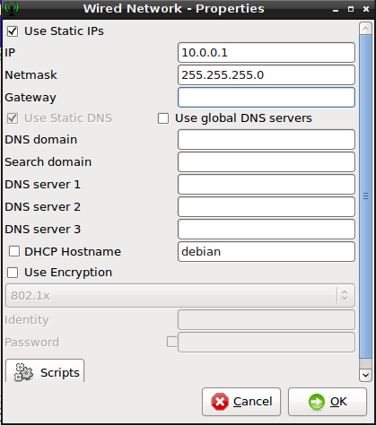
     3. Check/verify the use static IPs is checked.
     4. Enter the appropriate IP address and NetMask from the table above. Leave the Gateway blank (the configuration tool may fill in a gateway address, this is not correct so delete the address).
     5. Click OK then close to complete the configuration.
     6. To force the changes to take effect, click the Disconnect button, the button will change to Connect, then click the Connect button (if there is no Disconnect button just click the Connect button).  
        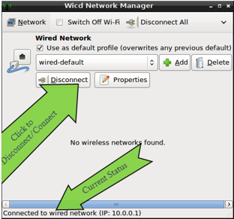
  4. Verify the changes have been applied.
     1. Open LXTerminal and use the ifconfig (or ip address) command to verify your network changes. You should see the newly configured addresses. If you don’t see the new addresses the change was not applied. In that case open the network manager and disconnect and connect the network. If the change still does not take place reboot the VM.

# Task 2—testing connectivity

Now you will make sure your machines are configured correctly by testing connectivity using a simple tool called ping. Ping uses the ICMP protocol to send a packet of data to the destination computer, the destination computer will then send a response back. If you get a response you have network connectivity. The Linux ping command will ping forever if you don’t specify the count. The ping command looks like this   
**ping –c <count> <destination IP>**  
If you forget the count it will just ping forever, you can stop ping using CTRL+C.

If successful your output would look something like this:  
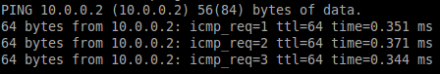

An unsuccessful one might look like this:  
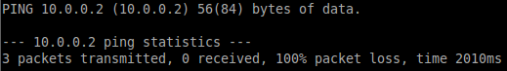

## Steps

1. From your Debian-1 VM
   1. Open LX terminal
   2. Test connectivity to Debian-2 with the command **ping –c 3 10.0.0.2**
      1. Was the ping successful? Yes
      2. If successful how long did it take? .303
      3. If not what was the error? None
   3. Test connectivity to Debian-3 with the command **ping –c 3 10.0.0.3**
      1. Was the ping successful? Yes
      2. If successful how long did it take? .402
      3. If not what was the error? None
2. From your Debian-2 VM
   1. Open LX terminal
   2. Test connectivity to Debian-3 with the command **ping -c 3 10.0.0.3**
      1. Was the ping successful? Yes
      2. If successful how long did it take? .208
      3. If not what was the error? None
3. If all the pings are not successful troubleshoot until it works. The problem is most likely either the VM being on the wrong virtual network, or the IP address is not configured correctly. You can view the current IP address with the command **ip address**. Your network adapter is **eth0**.

# Task—3 exploring the effects of network segmentation

Now you will move two of your VMs to a new network and explore the effects. VMWare Player’s Network segments are a virtual version of a Local Area Network. By configuring some computers to be on different network segments you effectively put them on different LANs. Recall that machines on different LANs cannot communicate directly with one another.

## Steps

1. Reconfigure your network by moving some VMs to a different LAN
   1. Edit the VM settings for both your Debian-2 and Debian-3 VMs to use **VMnet12**.
2. Predicting the results. What do you think will happen?
   1. Will the machines that changed network segments get different IP addresses? No they’re set to static IP’s
   2. Should Debian-1 be able to communicate with Debian-2? No Explain They’re not wired together
   3. Should Debian-1 be able to communicate with Debian-3? no Explain They’re not wired together
   4. Should Debian-2 be able to communicate with Debian-3? Yes Explain They’re on the same LAN
3. Testing your predictions
   1. Test connectivity with ping
      1. **From your Debian-1 VM** 
         1. Test connectivity to Debian-2 with the command **ping –c 3 10.0.0.2**
            1. Was the ping successful? No
            2. If not what was the error? 100% packet loss
         2. Test connectivity to Debian-3 with the command **ping –c 3 10.0.0.3**
            1. Was the ping successful? No
            2. If not what was the error? 100% packet loss
      2. **From your Debian-2 VM** 
         1. Test connectivity to Debian-3 with the command **ping** **–c 3 10.0.0.3**
            1. Was the ping successful? Yes
            2. If not what was the error? none
4. Did the results match your predictions? Yes If not explain none

# Task—4 exploring the effects of logical network segmentation

|  |  |  |  |
| --- | --- | --- | --- |
| VM | IP Address | Subnet Mask | Network Address |
| Debian-1 | 10.0.1.1 | 255.255.255.0 | 10.0.1.0 |
| Debian-2 | 10.0.2.2 | 255.255.255.0 | 10.0.2.0 |
| Debian-3 | 10.0.2.3 | 255.255.255.0 | 10.0.3.0 |

In this task you will return your VMs to a single network segment, then reconfigure the IP addresses to place the machines in different logical networks. You will then explore the results. The new addresses are as follows. Remember that the Network Address is determined by replacing the last number in the IP address with a zero. Complete the following table:

## Steps

1. Return Debian-2 and Debian-3 to **VMNet11**.
2. Test to ensure connectivity between VMs.
3. Reconfigure the IP address for your virtual machines according to the table above.
4. Verify your changes with **ifconfig** or **ip address**, restart the network service if necessary (Probably will be).
5. Are all the VMs on the same physical network (explain)? Yes since they’re all plugged into the same network
6. Are all the VMs on the same logical network (explain)? No since they are on different subnets
7. Predicting the results. What do you think will happen?
   1. Should Debian-1 Be able to communicate with Debian-2? No Explain They’re on different subnets with a different network address
   2. Should Debian-1 Be able to communicate with Debian-3? No Explain They’re on different subnets
   3. Should Debian-2 Be able to communicate with Debian-3? Yes Explain They’re on the same subnet
8. Testing your predictions.
   1. Test connectivity with ping.
      1. **From your Debian-1 VM** 
         1. Test connectivity to Debian-2 with the command **ping –c 3 10.0.2.2**
            1. Was the ping successful? No
            2. If not what was the error? Destination Host Unreachable, 100% packet loss
         2. Test connectivity to Debian-3 with the command **ping –c 3 10.0.2.3**
            1. Was the ping successful? No
            2. If not what was the error? Destination Host Unreachable, 100% packet loss
      2. **From your Debian-2 VM**
         1. Test connectivity to Debian-3 with the command **ping** **–c 3 10.0.2.3**
            1. Was the ping successful? Yes
            2. If not what was the error? None
9. Did the results match your predictions? Yes If not explain None

# Task—5 further exploration

Now you will experiment a bit further and speculate regarding network problems

Steps

1. Try to ping google.com from Debian-1
   1. Enter the command  
       ping –c 3 google.com
   2. What was the result? Temporary failure in name resolution Speculate why it was or was not successful. Debian1 doesn’t have DNS to find the domain name google.com
   3. I happen to know that one of Google’s IP addresses is 74.125.239.23 try pinging by the IP address with the command  
       ping –c 3 74.125.239.23
   4. What was the result? Network is unreachable Speculate why it was or was not successful. Debian1 doesn’t have internet at all since it’s not on the WAN
2. Configure Debian-3’s network adapter to use NAT rather than a LAN segment.  
   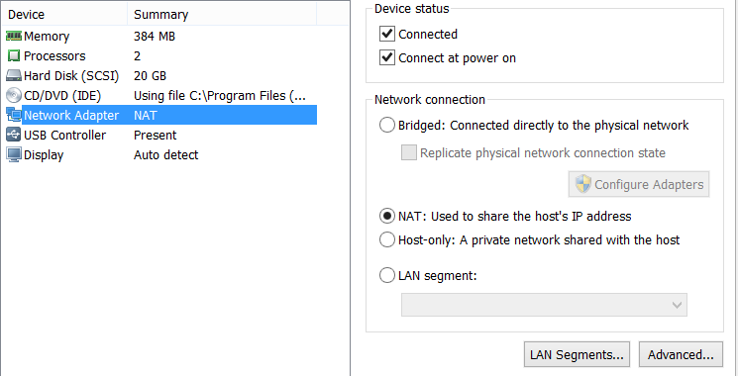
3. Return Debian-3 to automatic IP address configuration. **Uncheck** the **Use Static IPs** and **Use Static DNS check** boxes.  
   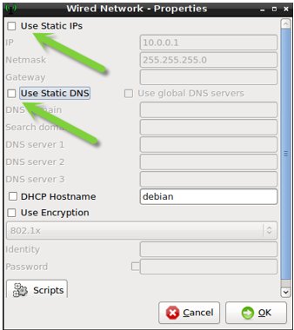
4. Click **OK** to save your changes then force the changes to take effect by **Disconnecting** and **Reconnecting** your network.
5. After the network restarts use **ifconfig** or **ip address** to view the IP address. What is the IP address? 192.168.136.135
6. Try to ping google.com from Debian-3
   1. Enter the command ping **–c 3 google.com**
   2. What was the result? Successful Speculate why it was or was not successful. It was successful since we’re now sharing the hosts internet so we have access to DNS and DHCP.

# Wrap-up

Shutdown your virtual machines.

# Deliverable

Upload this document with completed answers to canvas.